

*♬ BOThoven ♬*

the musically interactive robot

05/05/2016

By: Jason Arnold, John Halloran

BOThoven: the musically interactive robot

Jason Arnold, John Halloran

[jason.arnold@marquette.edu](mailto:jason.arnold@marquette.edu), [john.p.halloran@marquette.edu](mailto:john.p.halloran@marquette.edu)

**ABSTRACT**

In this paper, we discuss our development of our musical assistant, BOThoven for our class COEN 4890 Development in Computer Applications: Human Robotics Interaction here at Marquette University. In order to fully understand how we began with this project, we will attempt to describe our musical backgrounds and which strengths benefitted which part of the robot.

**BACKGROUND**

The creators of the robot, John Halloran and Jason Arnold, have both been interested in music from a very young age. Although Jason was formally trained as a percussionist throughout his childhood, he took a casual approach to learning music. In his later years, his professionally trained rhythm progressed into a further interest in tonality and harmonies. He later picked up guitar and singing, relying on his ear to identify major, minor or poorly executed note interaction. John, on the other hand is a jazz trained bassist with heavy focus on improvisation. John also has a formal education of music due to his pursuit of a music minor. Recently John has been training in a classical sense focusing primarily on string bass as he performs with the Marquette Wind Ensemble. As part of his minor studies, John has studied under Dr. Erik Janners as a conductor.

**DESIGN**

Just as John and Jason differ in their musicality, so does every musician in their own. In order to address the endless varieties of musical interests, we decided to focus on the one shared aspect of music: rhythm. Rhythm, although the unifying element of all music, can present differences on its own (e.g., classical rhythm, acoustic rhythm, etc.).

Our team was excited to tackle this project as we had both a formally trained classical musician as well as a casual acoustic musician. By focusing on rhythm, we can not only unite our ideas of music into BOThoven, but we can provide musicians with a diversely developed musical assistant. The benefits of this combination became immediately evident even just designing the implementation of the rhythm. As an informal musician, Jason identified the best rhythmic-management solution as an audible click or metronome. Formally trained, however, John felt that visual rhythmic representation was the most beneficial and universal way to represent rhythm.

As a musical robot, obviously incorporating both a microphone and speaker into the bot was an obvious choice. Both recording and playback is an essential aspect to both classically and informally trained musicians.

**IDEATION**

In order to emphasize the most important aspects of BOThoven, we made sure to focus on what we as musicians find the most important during practice. As stated above, the rhythmic focus is key to the functionality of the bot. In order to emphasize every beat BOThoven attempts to visually portray, we made sure to integrate an elongated baton.

Rhythmic representation was not the only beneficial aspect of the team’s musical variety. Originally we had hoped to program the robot to play a specific instrument in conjunction with another musician. However, in order to capture a wide variety of musical tastes, we decided to implement a speaker to play a variety of pieces to accompany the artist, as well as provide that audial rhythmic click to keep the musician on beat.

Our decision to stray from specific musicality was not an easy move, especially for the classically trained. However, we found it most beneficial to focus on the most universal aspect of music for a wider user-base rather than specific instruments and implementations. However, the recording of a performance will allow the musician’s own ear to train and further identify mistakes in their piece. Furthermore, sending files of recordings seemed to be an essential factor. BOThoven can send you an email containing an mp3 recording of a musician’s practice or performance.

**PROTOTYPE**

Our prototype followed our ideation process very closely. As you can see below, the elongated and emphasized arm in order to clearly demonstrate the downbeat. The interactive and friendly face keep musicians calm during practice. Also, it is worth noting that our prototype also has a thin and unreliable base. When the arm moves, the base became a bit shaky. However, a quick fix is noted behind the bot, adhering a block for stability to the back.

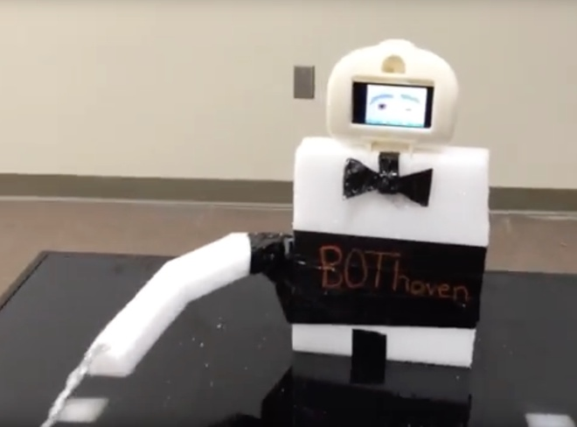

**FEEDBACK**

We received a great amount of feedback regarding the functionality of BOThoven. As we stated in our Design section, implementing musicality into BOThoven may exclude many users from using it. Nonetheless, that was a major suggestion from users. Although we can play mp3 files through BOThoven’s speakers, many musicians would’ve enjoyed a synchronization of the arm to the music. This functionality requires many more resources beyond the scope of this project.

In addition to the musical syncing, musicians also desired a cleaner audio playback from our robot. Unfortunately, both the metronome and our robot’s motion were heard on the playback recording. This noise could be reduced with both software and hardware integrations. A microphone for the musician would reduce external noises significantly. In addition, there is plenty of noise reduction software that would be able to reduce all noises other than the designated instrument, whether that be a singer’s voice or a jazz musician’s bass.

**CONCLUSION**

Overall, our robot is an incredibly beneficial musical assistant. With functionalities that range from rhythmic assistance to audio feedback, musicians can finally attain that “group practice” feel on their own. After adding BOThoven to our very own musical practices, we found that the efficiency of both the speed and performance of our practice increased. The design of this robot has been simplified in order to ease the use for the musician and keep focus on the motion of the conductor’s arm. Not only will this increase a musician’s desire to practice, but it will improve their results as well.

**REFERENCES**

B., Susan, “Classroom Teachers’ and Music Specialists’ Perceived Ability to Implement the National Standards for Music Education,” Fine Arts Academy of Rio Rancho, Rio Rnacho, NM, 1999.

G. Weinberg, A. Raman, and T. Mallikarjuna, “Interactive jamming with Shimon,” Proceedings of the 4th ACM/IEEE international conference on Human robot interaction - HRI '09, 2009.

G. Hoffman and K. Vanunu, “Effects of robotic companionship on music enjoyment and agent perception,” 2013 8th ACM/IEEE International Conference on Human-Robot Interaction (HRI), 2013.

T. Hashida, T. Naemura, and T. Sato, “A system for improvisational musical expression based on player's sense of tempo,” Proceedings of the 7th international conference on New interfaces for musical expression - NIME '07, 2007.

G. Weinberg and S. Driscoll, “Toward Robotic Musicianship,” Computer Music Journal, vol. 30, no. 4, pp. 28–45, 2006.

Trotter, Robert J. "Robots Make Intelligent Teachers." Science News 104.5 (1973): 76. Society for Science & the Public. Web. <http://www.jstor.org/stable/3958577>.

Allsup, Randall Everett. "Mutual Learning and Democratic Action in Instrumental Music Education." Journal of Research in Music Education 51.1 (2003): 24. SAGE. Web. <http://www.jstor.org/stable/pdf/3345646.pdf>.

Feay-Shaw, Sheila. "Multicultural Perspectives on Research in Music Education." Bulletin of the Council for Research in Music Education 145.Summer (2000): 15-24. University of Illinois Press. Web. <http://www.jstor.org/stable/pdf/40319019.pdf>.

Holland, Simon. "Artificial Intelligence, Education and Music: The Use of Artificial Intelligence To Encourage and Facilitate Music Composition by Novices." Open Univ., Walton, Bletchley, Bucks (England). Inst. of Educational Technology, July 1989: 305. http://files.eric.ed.gov/fulltext/ED329452.pdf.